**ONLINE MOVIE BOOKING SYSTEM**

**APTECH PR-202001C1**

**GROUP ASSIGNMEMT ACCP PRIME**

**FAIQ YASEEN: 1256162**

**SYED FARAS: 1150621**

**M. SUFIYAN: 1256023**

**HAND OUT DATE: 13-AUG-2021**

Contents

ACKNOWLEDGEMENT 3

INTRODUCTION 4

PROBLEM STATEMENT 4

PROPOSED SOLUTION 4

CUSTOMER REQUIRMENT SPECIFICATION 5

PROJECT PLAN 6

DESIGN ERD-DIAGRAM 6

GUI STANDARD DOCUMENTS: 8

ADMIN PANEL 12

ALGORITHMS 14

UNIT TESTING 16

TASK SHEET 20

# ACKNOWLEDGEMENT

The success and outcome of this project required a lot of guidance and assistance from many people, and I am extremely privileged to have got this all along the completion of my project. All that I have done is only due to such supervision and assistance and I would not forget to thank them.

I respect and thank Lecturer Sir Ali, for providing me an opportunity to do the project workand giving us all support and guidance, which made me complete the project duly. I am extremely thankful to him for providing such a nice support and guidance, although he had busy schedule teaching the students.

Besides, we would like to thank the APTECH SHAHRA-E-FAISAL for providing a great facility and studying environment which included well-equipped computer labs for student to learn and hand on for the practical training.

# INTRODUCTION

Thanks to the advent of internet, several people are booking their favorite seats online. They can also enjoy promotions and discounts with cheap movie vouchers. You can watch more movies with your family nowadays as it is easier to buy movie tickets at affordable prices. At the comfort of your home, you can buy movie tickets online and get the seats you want. The best part of looking for movie tickets over the web is that you can make selection of various movies along with both indie films and big banner films. You can pay with your credit card to buy cheap movie tickets. You can also pay with your internet banking account. Another best thing is that you do not have to stay in queue and wait for your chance to buy tickets on the window.

# PROBLEM STATEMENT

Watching movies is one of the entertainment mediums these days. People need to surf various website to watch trailers of the movies. They need to browse through different websites to get the movie review. Once they find a movie suited to their liking, they need to go to theatres to book ticket. For this they need to stand in queues to buy tickets. To ease all these problems, we have proposed a solution as Online Movie Ticket booking.

# PROPOSED SOLUTION

* Online movie booking system is a web portal where you can book tickets in advance, know your movie show timing, watch movie trailer, and read reviews for the same.
* User can know everything about a movie and its show rates and show time just sitting on your couch.
* Just go to web portal for Online Movie Ticket Booking System and register yourself and gain access to all the movie and theaters and many more features.
* Online Movie Ticketing System in PHP is a very user-friendly project and can be accessed from anywhere.
* There is no need to go to the movie theaters and wait for your turn to book movie tickets.
* User can now just track everything about a movie just by clicking on to it.
* User can buy tickets just by selecting a movie and show timings. Also, there is three classes for a movie theatre.
* User can opt to Gold, Platinum or Box class to buy tickets. These are different seat categories inside the hall.

# CUSTOMER REQUIRMENT SPECIFICATION

**System users-**

The Visitors or the Registered users

The admin (Who is responsible to update the portal)

**Role:**

***Visitor or Registered user:***

* He/she needs to first register on this web portal.
* He /she can enjoy watching trailer for movie.
* He/she can book movie ticket by selecting show time and show date.
* He/she can opt to our three classes and can select any one of the three classes.
* We have special concessions for kids (aged between 3 to 12 years).
* He/ she can read movie details and reviews along with their ratings at our web portal.

***Admin***

* Admin is the main backbone for this portal.
* Admin is responsible for adding and editing a movie theater.
* Admin will add, edit, and delete movies for each movie theaters.
* Admin will be responsible for adding, editing, and deleting show time for movies.
* Admin can also view the number of users that are registered to the web portal.

**Online Movie Booking system features**

* Login and Registration for users.
* View show time just by selecting your preferred date.
* Movie Reviews and ratings.
* Movie trailers.
* Payment Gateway needs to be added to this project. (Optional)
* Admin dashboard.
* Add, delete, and edit movie theaters.
* Add, delete, and edit movies.
* Add, delete, and edit shows and their rates for each class.

DESIGN ERD-DIAGRAM:

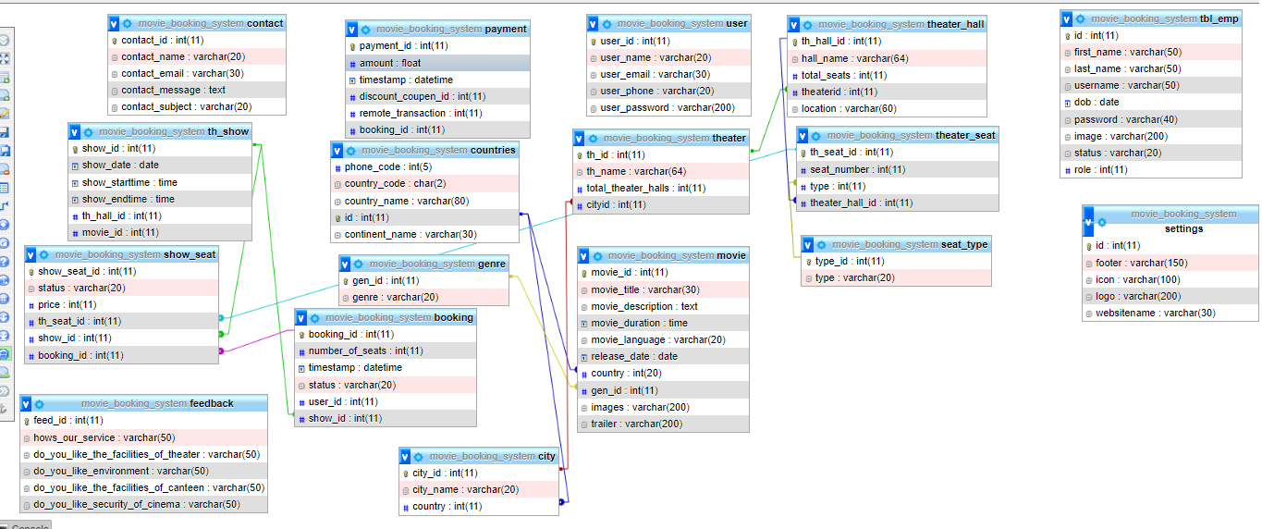

# 

# GUI STANDARD DOCUMENTS:

SIGN UP

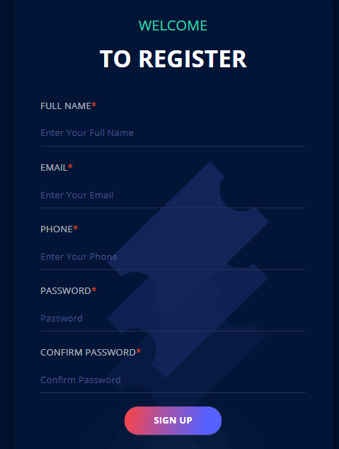

This is the sign-up page for my Online Movie Booking System, through Signing up on this you can successfully login into your account. Through Signing up new users can create their account easily and enjoy the favourite movie selections with their desired date and timings.

LOGIN PAGE

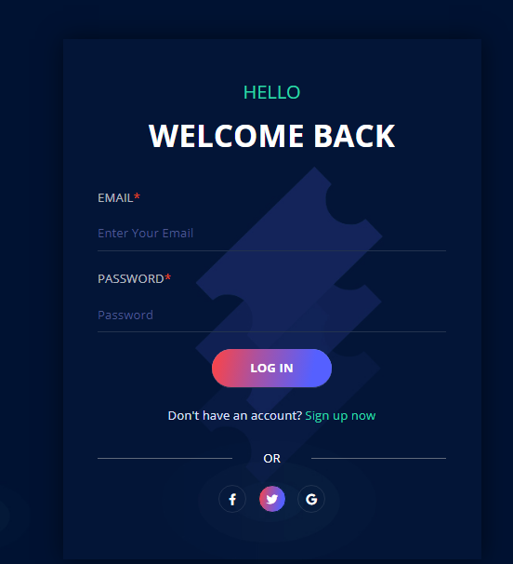

Once you are done with Sign Up you are registered for the website, so users need to enter their correct Email and Password to access the website

HOME PAGE OF WEBSITE

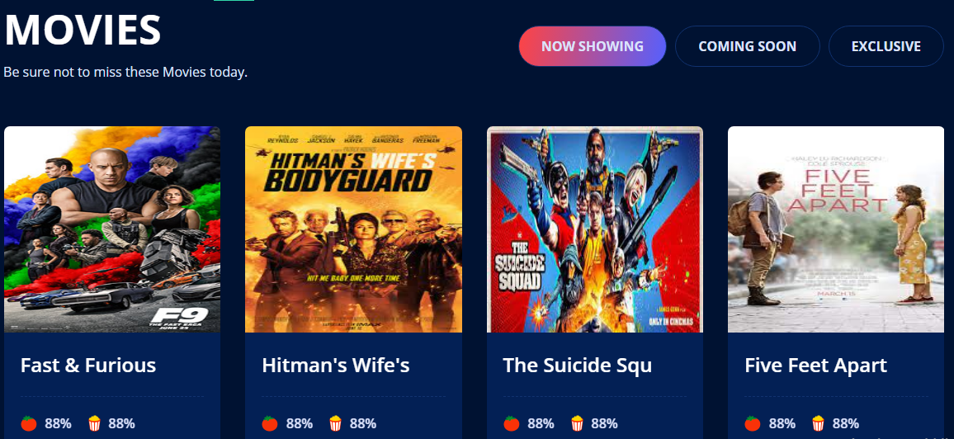

# ADMIN PANEL

EMPLOYEE CRUD

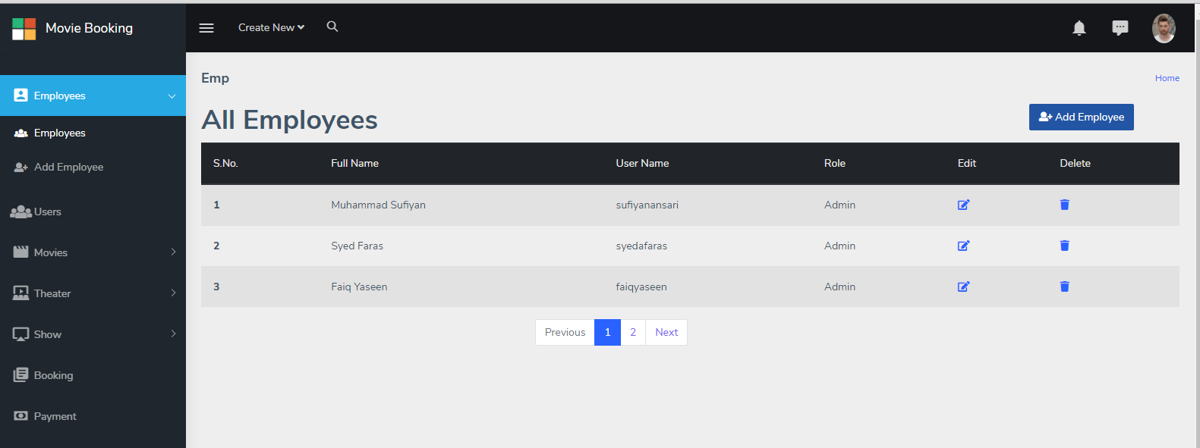

This is the Admin Panel here Admin can Create, Update and Delete the new employee to the website and make any changes he wants to do.

MOVIE CRUD

This is the Page for Movies CRUD here Admin can create, update, and delete the movie name. Whenever are their new movies so he can easily update or replace with the older ones.

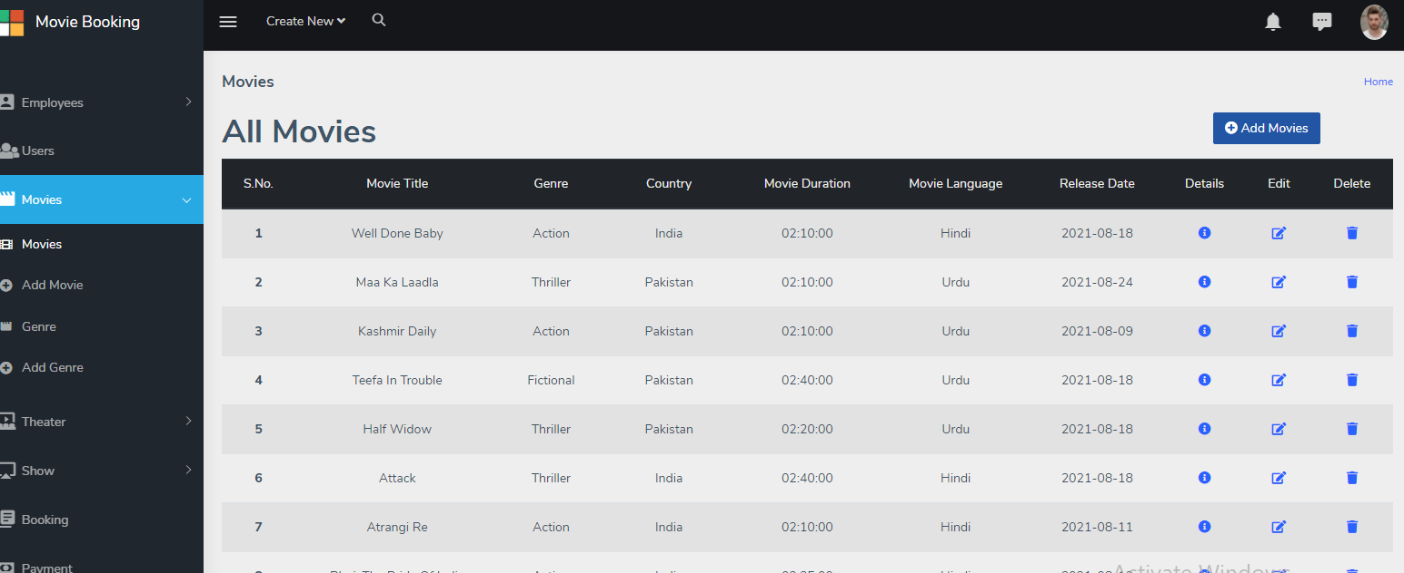

SEATS CRUD

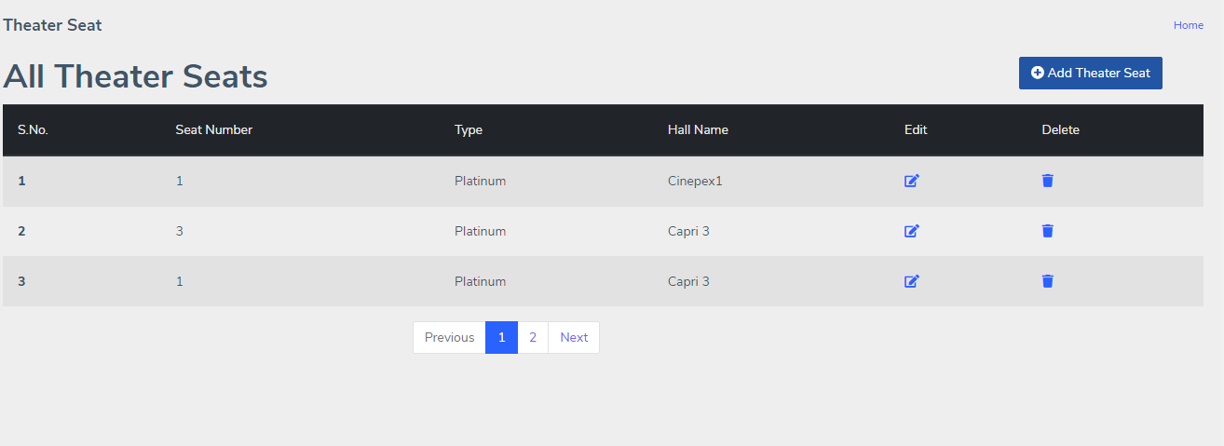

This is the categories of seats with their prices. This can help Admin to see which show has a more seats book and Admin can perform his Crud according to his wish.

# ALGORITHMS

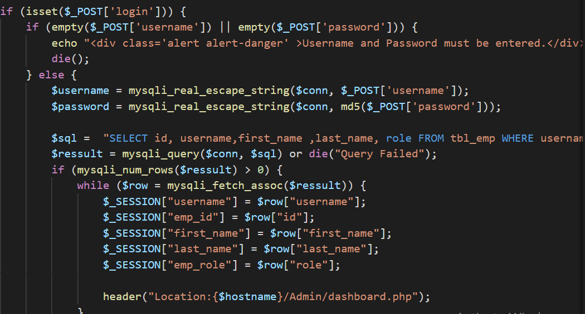

When you Create Database in MySQL so this is the how you have to make the connection to the database by mentioning the username and password of your MySQL and with your server’s name.

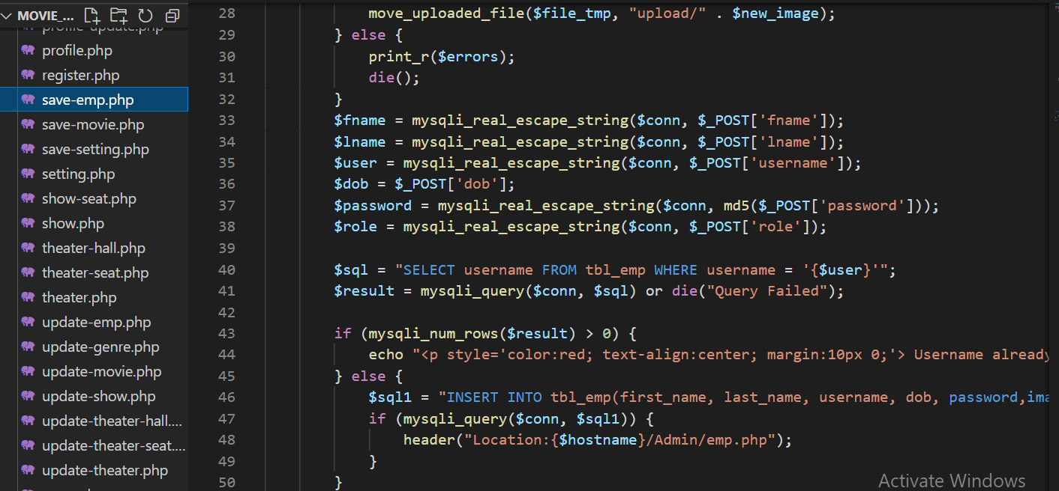

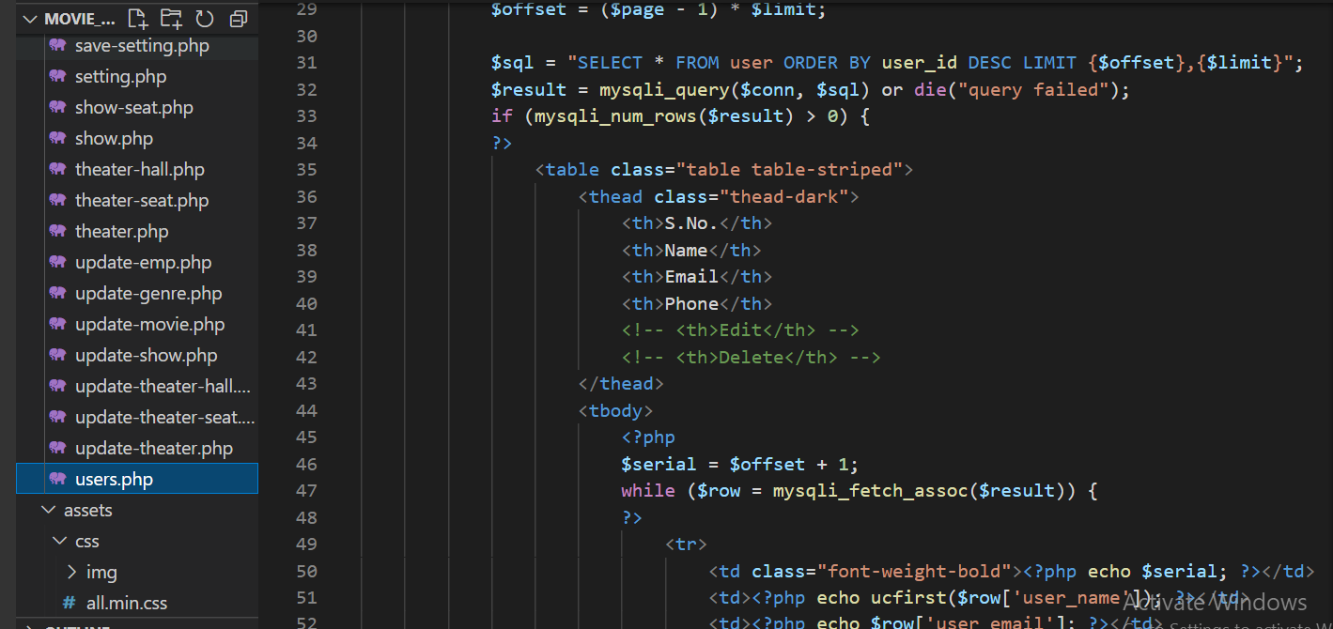

This Query is for Displaying of Records.

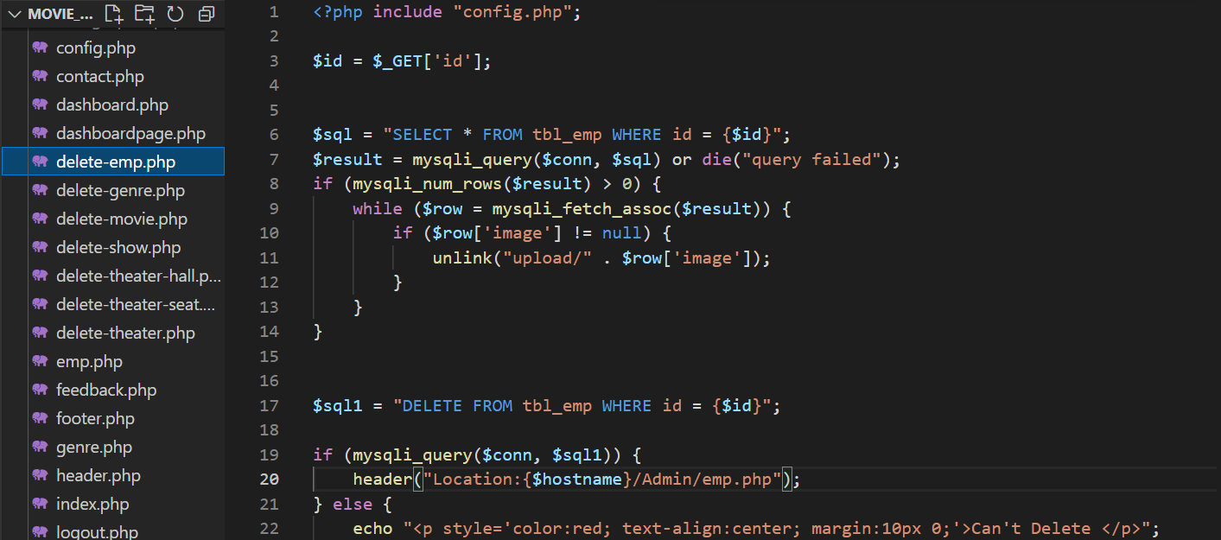

Admin has right to Delete the record from the Table.

# UNIT TESTING

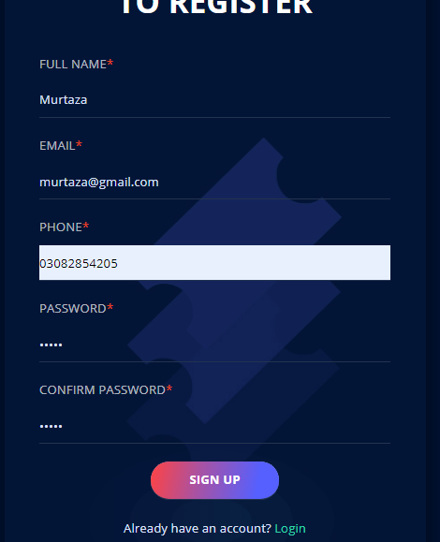

The new record is just created for the new users after entering all his information user will click on sign up.



The record is added in the MySQL database.

Admin is entering the records of User manually.



After the Admin added the data is showing into the list.

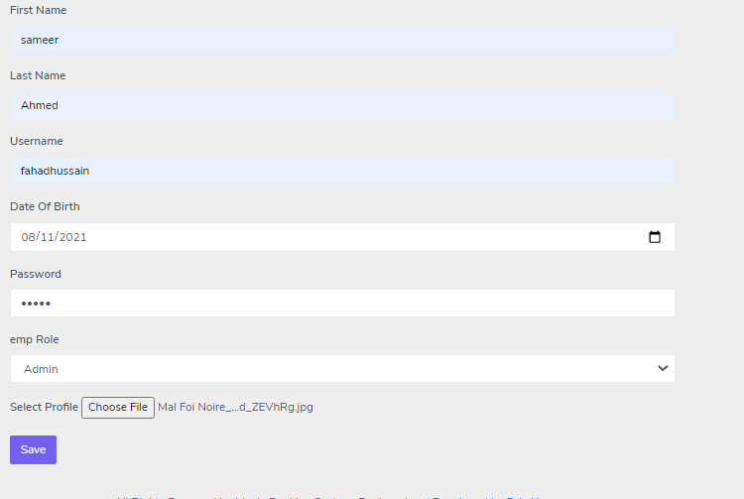

If later Admin wants to any of the information to be Updated so it can easily be done by doing this.

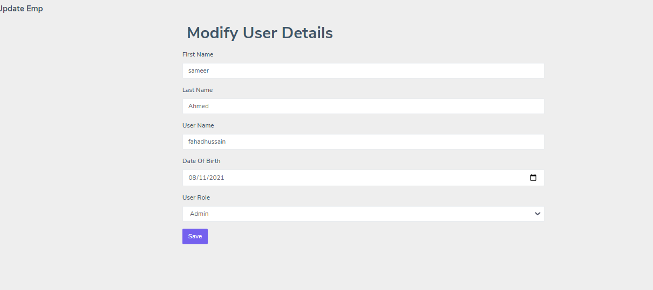

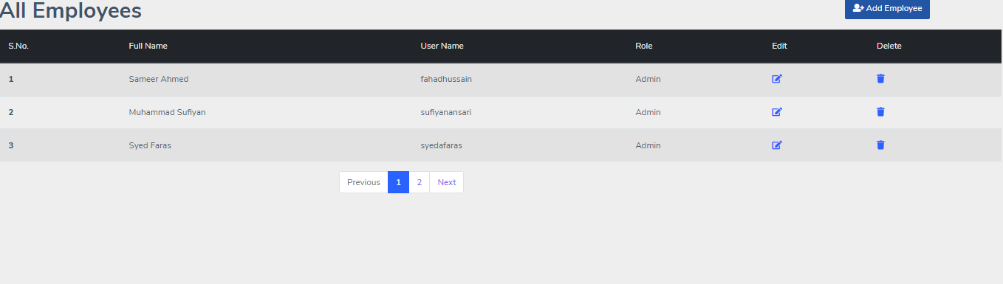

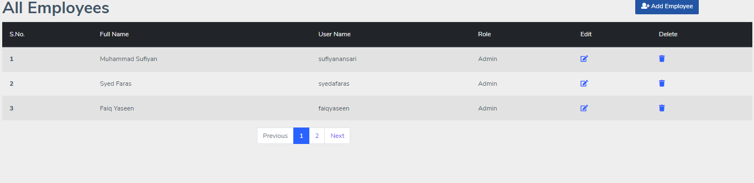

The data which is added by the user is now deleted and it is not available in the list as well.

# TASK SHEET

|  |  |  |
| --- | --- | --- |
| Name | Task | Signature |
| FAIQ YASEEN | Admin Panel with the backend Coding, Implement the Queries. |  |
| SYED FARAS | MySQL Database Designing and Frontend. |  |
| M.SUFIYAN | DOCUMENTAION AND HTML & CSS |  |